**CTF Topic: DNS Spying with DNSSpy**



**1. Introduction**

DNS spying involves analyzing DNS records to gather information about a domain's configuration and potential security issues. The DNSSpy tool provides insights into the DNS setup, highlighting any vulnerabilities or misconfigurations that might be present.

**3. Scenario**

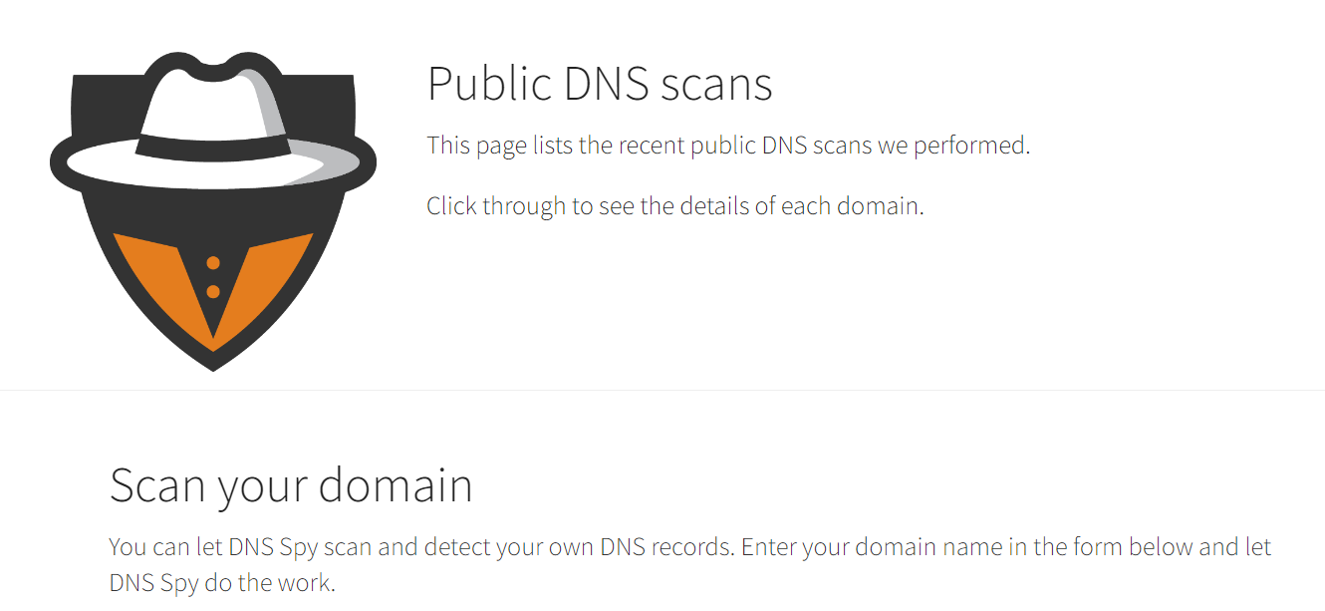

As a participant in this CTF challenge, your task is to use the DNSSpy tool to analyze the DNS records of **`testphp.vulnweb.com`**. Perform the analysis and answer the following questions based on your findings.

**4. Process to Follow while performing CTF**

Step 1: Visit the DNSSpy tool using the provided link: [**https://dnsspy.io/scan**](https://dnsspy.io/scan)

Step 2: And Enter **vulnweb.com** to scan its DNS records.

**Questions and Answers**

Flag 1: What is the location of IPV4 of name server ns2.eurodns.com.

Answer: US

Flag Captured.

Flag 2: What is the ISP of the name server ns4.eurodns.com.

Answer: AS23393 - NUCDN, US

Flag Captured.

**Hint**

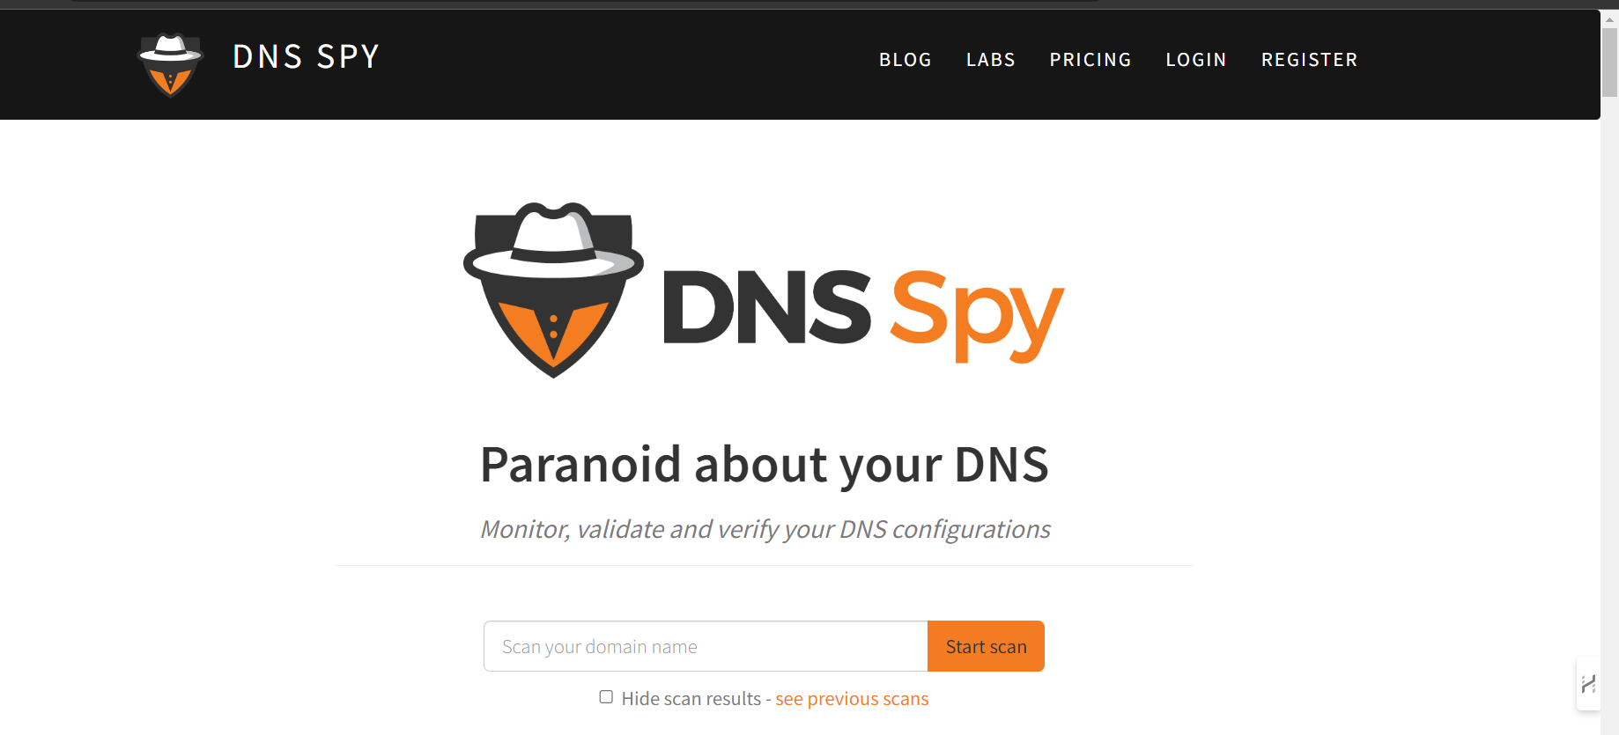

Use the DNSSpy tool to scan the DNS records for `testphp.vulnweb.com`. Pay attention to details such as IP addresses, TTL values, MX records, SOA records, and other DNS record types. Look for any configurations that might pose security risks.

